# Burgess Park Outdoor Cooking Area Trial

## Evaluation Report: November 2024

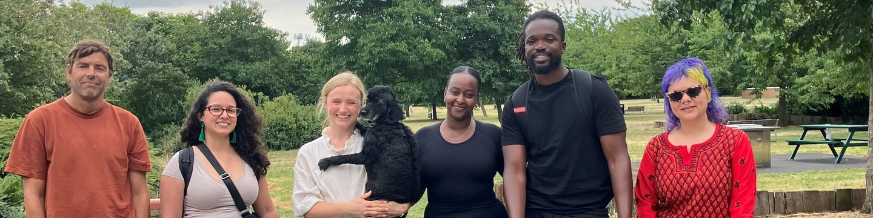

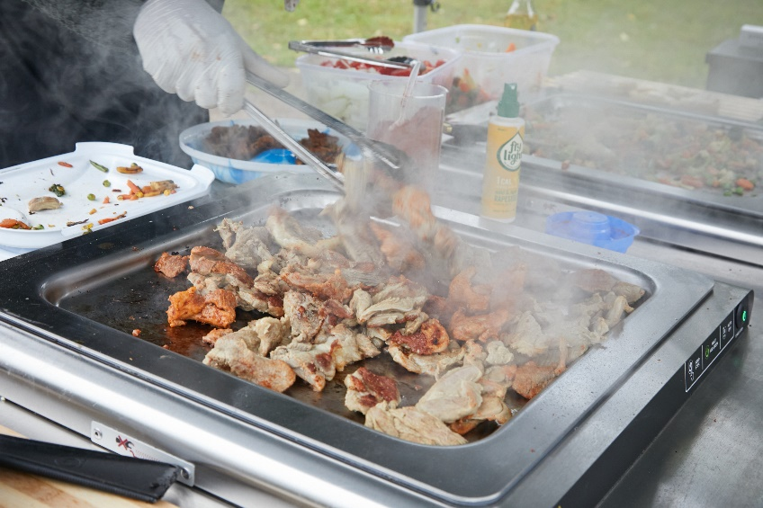

Contents

Burgess Park Hotplate Trial 1

Evaluation Report: November 2024 1

Contents 2

Introduction 3

Background 3

Evaluation 4

Design methods: 4

Results of evaluation: 5

Findings summary 7

Conclusion and recommendations 8

Appendices 10

## Introduction

This report examines the impact of the Burgess Park Outdoor Cooking area trial held between 9 August 2024 and 27 October 2024. Its aim is to:

* Assess the success of the project
* Identify strengths and areas for improvement
* Provide evidence-based recommendations for the future of Outdoor Cooking in Burgess Park

The evaluation was undertaken by the Burgess Park Outdoor Eating Working Group (BPOEWG) made up of council officers from the Parks and Communities teams, ward councillors, VCS organisations including Pembroke House, Latin Elephant and InSpire Walworth, and residents from the local area.

## Background

Following the positive experiences of collaborative working during the Covid-19 pandemic Pembroke House and the council wished to explore how to develop and sustain new ways of working learning from the best of that experience. In 2022 the Department for Levelling Up, Housing, and Communities (DLUHC) launched its Partnerships for People and Place pilot project and Southwark successfully bid with Pembroke house to deliver the ‘We Walworth’ project to test new ways of collaborative working. Building on the earlier work, the focus of the project was food and addressing food poverty in the area around Pembroke house and Faraday ward.

Through ‘Neighbourhood Gathering’ events, and on-street activity resulting in over 700 conversations, We Walworth identified the closure of the BBQ area in Burgess Park during the pandemic as an issue of concern for many in the community, but one that had a range of interests and positions and potential solutions.

We Walworth, Pembroke House and council officers worked together with residents, Friends of the park, local councillors, park staff and parks service team, to build a vision for the future of the BBQs in Burgess Park. The vision set out the groups ambition:

BBQs in Burgess Park are reopened as a sustainable facility, that is:

* *well used, owned and cared for by communities, for communities*
* *can provide a place to celebrate home, community and belonging*
* *are well used by Southwark's diverse communities, and everyone feels welcome and included*
* *the risks and rewards are shared by all stakeholders*

The delivery of this vision was reaffirmed in June 2024 as the continuing vision of the Burgess Park Outdoor Eating Working Group.

In addition, the community discussions also identified the work to successfully build this vision and make it a reality, needs to address the following themes:

1. New approaches to **resourcing and ownership**
2. Increasing **accountability and access** around the BBQs
3. Ensuring the sustainability of the BBQs through **improved facilities**
4. Using the BBQ space to **bring the community together**

The vision and themes were presented to decision makers in January 2023. A Project Officer was allocated to work on the project later in the year.

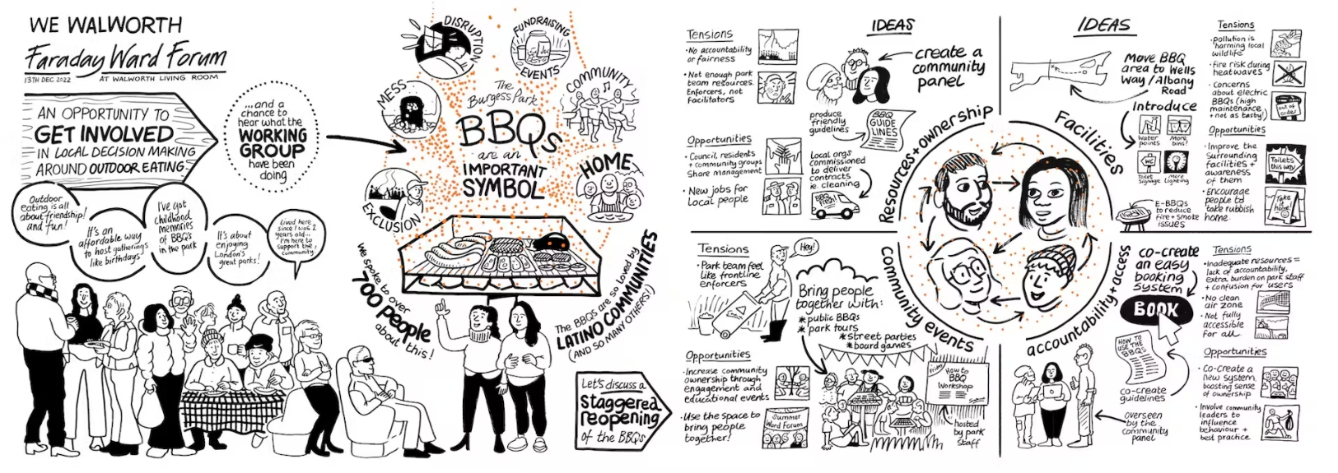

A working group was set up to implement the pilot project and manage the evaluation as well as make recommendations about the next steps to council decision makers. The working group was composed of Council Officers, Inspire, members of We Walworth steering group and then at its ending Latin Elephant and, Ward Councillors and was facilitated by staff from the Consultation and Involvement team.

The council allocated a budget for a pilot project to test the ideas that emerged from the vision, with a community session to support the design of the new outdoor eating area hosted by We Walworth.

The pilot programme involved the installation of three electric hotplates in the Wells Way/Albany Road area and these were open to public use on 9 August 2024. The evaluation plan was drafted to examine each of the theme areas and issues that emerged during the vision setting.

The pilot was open from 9 August to 27 October 2024. This was later than anticipated but has enabled us to test several of the theme areas although not all.

## Evaluation

### Design methods:

The evaluation combined quantitative and qualitative data collection to ensure a comprehensive analysis. Quantitative and some qualitative data was gathered through an online public survey. Additional qualitative insights were gathered through conversations with key stakeholders including the parks team, hotplate and park users, and through observational studies.

Limitations to the evaluation:

* Project delays meant the evaluation wasn’t held over the full length of the summer season
* Not all elements of the vision could be fully explored or tested due to the short evaluation period e.g. community events
* There were 49 responses to the online public survey
* Not all responders provided equalities data, so we don’t have a full picture of the ethnic background of those who completed the survey

The working group evaluated the data together to ensure all perspectives were considered and included in the evaluation.

### Results of evaluation:

Below is a summary of the results from the online survey, parks team feedback and observational studies.

**Online survey summary:**

There were 49 responses to the online survey:

* 17 felt that the new hotplates are an improvement on the previous charcoal BBQ area due to being quicker, more efficient, and safer for children.
* 8 preferred the charcoal BBQs for their authentic taste and community feel, suggesting that the electric hotplates do not offer the same experience.
* Ethnic background of respondents: 9 Latin American, 17 White, 3 Black, 3 Asian, 17 didn’t respond to questions about their race.
* 27 of the responders identified as not having access to private outdoor space while 11 did.
* The people who took part were a mix of first time (16) and regular hotplate users (13) and some who hadn’t used the hotplates (18).
* 21 of the people who responded had used the previous BBQ facilities in the park.
* Most people who answered (41) either walked or cycled to the park with 34 coming from Peckham, Walworth or Camberwell.
* Those who made suggestions for improvements said they would like more hotplates (9), more water fountains (6), more toilets (4), more seating (3)

## Findings summary

Overall, the hotplates were positively received with the majority appreciating the outdoor cooking area returning to Burgess Park. The evaluation highlighted the following strengths and areas for improvement:

Strengths

1. People positive about the hotplates:
   1. Users appreciated the ease of use, design, and performance of the hotplates.
   2. Recognised as an improvement over the previous charcoal BBQ area in terms of efficiency, safety, and speed.
   3. Observation visits confirmed consistent cleanliness, and positive user engagement, highlighting users are taking care of the site.
2. Inclusivity:
   1. The hotplate site attracted a mix of first-time, regular, and interested passers-by, indicating potential to broaden user demographics.
   2. Insights from diverse perspectives.
3. Clear Improvement Opportunities:
   1. Users and officers identified specific areas for enhancement. Some of these have begun already e.g., instructions provided in multiple languages.
4. Community Interest:
   1. Interest and engagement during observation visits and in the online consultation demonstrate the area's potential for fostering increased community involvement.

Areas for Improvement

1. Cleaning and Maintenance Challenges:
   1. Lack of cleaning facilities and water sources is a major issue, making it difficult for users to clean hotplates effectively.
   2. Parks team reported more time was needed to clean compared to the old BBQ area, mainly due to litter but they expressed a view that this was currently manageable with existing resources. In addition, littering improved with better signage.
2. Littering and Hygiene Concerns:
   1. Increased littering e.g., bottles, food waste and misuse of shrub borders for toilets raise concerns.
   2. Some users need clearer instructions on site use and better access to facilities such as access to water and toilets.
3. Mixed Preferences:
   1. Eight users preferred the authentic taste and community feel of charcoal BBQs over electric hotplates.
4. Extended Use and Accessibility:
   1. Some groups remained near hotplates after use, potentially limiting access for others, although this was perceived by some as a positive highlighting that it suggested that the hotplates were acting as an area that was bringing the community together. There was one incident when a warden was asked to intervene to enable access by a small group.
5. Anti-Social Behaviour:
   1. While not specific to the hotplates, complaints about noise, litter, and misuse of park facilities, highlight broader management challenges in the park.

## Conclusion and recommendations

In conclusion, the hotplates have been well-received for their ease of use, safety, and ability to attract a range of users. Having the hotplates contributes to a more inclusive and engaging community space overall extending the role of our parks as a community hub. The working group acknowledges that the time for the trial was short and took place in a period where usage will be lower than in the peak of summer especially as late summer and early autumn had poorer weather this year. However, the evaluation has already provided some valuable insights into use and impact and we would like to share the following recommendations for the next steps.

**Recommendations:**

1. Continue to provide the existing hotplates.
2. Expand the provision with installation of a further 6 hotplates, at the Albany Road/Wells Way site, make these single units. This increase will mitigate concerns about high demand as the area becomes more widely known.
3. Install lids on the existing and any new hotplates to prevent rain penetration of oil trays and other contamination. (note the team is making additional improvements to run off from the hotplates)
4. Make publicly available the cleaning tools that are used by cleaning staff to facilitate people taking care of the hot plates. Ensure that they are able to reach all surfaces.
5. Install a water source close to the hotplates to facilitate cleaning and hand washing and to promote care of the hotplates and general hygiene. Consider the option of non-drinking quality water as a potential means to facilitate the installation.
6. Improve access to toilets to mitigate the use of the park bushes for toileting. It is recognised that there is no evidence that hotplate users are behaving in this way, however the development of this site has changed patterns of gathering in the park, and how different areas are used. During the working group no clear preferred mitigation arose, however there remains a need to address the problem of defecation and urination in this area. We recommend a further report setting out the options, with a Strengths v. Weaknesses analysis for each.
7. Make landscape improvements to the site, and use this as a tool to further manage inappropriate use of the area including toileting. Consider potential impacts of these changes in solutions discussed above.
8. Improve signage in and around the site and install a notice board. It was clear during the trial that improved signage acted positively to encourage better behaviours about littering. Consider how to make this accessible through easy read images and translation into community languages. Areas to review for our signage are:
   1. Wayfinding the toilet facilities
   2. Wayfinding water
   3. How to use and clean the hotplates
   4. Signage about litter
9. Increase the numbers of euro bins serving the site when the hotplates are on taking a dynamic approach to provision and decorate them to make the site a more pleasant.
10. We repeat the evaluation April 2025 to September 2025 to learn further lessons about the site and public use of the facilities.
11. We continue to meet jointly with community members quarterly, with its role to -
    1. review and support the plans for installation of new hotplates and the design and landscaping of the area
    2. consider the report on toilet facilities
    3. consider the second evaluation in October 2025

At the first meeting in March post budget decisions members can decide how they wish to work together on the next phases of the development of outdoor cooking in the park.

1. There were 11 people who said they were interested in getting more involved, these people should be invited to join the group.
2. Local VCS should be encouraged to host open air events at the outdoor eating area to further promote the facility and build community cohesion.
3. When the site reopens in spring add to the comms campaign information about the benefits of electric hotplates and why the council has selected this option rather reinstalling charcoal BBQs.

Implementing a booking system was one of the suggested facility management tools**.**  There is not currently a need for a booking system as overall users are managing the time they spend on the hotplates responsibly and without issue. A booking system would likely mean a cost for both the council and the user. We recommend that this is reviewed over the summer of 2025, to see if this changes as the hotplates become more popular.

Similarly, parking was raised as an issue at the former site but the move has meant that parking by hotplate users is not impacting local residents, and the survey suggests few people are driving to use the hotplates.

The evaluation suggests the site does not require management, and the suggestion of Local VCS management of the hotplates can be revisited as part of the next evaluation.

In the original ask there was discussion about community ownership of the site and people felt that the care the area was being shown by the hotplate users suggested that people had a sense of ownership.

## Appendices

Appendix 1 quantitative survey results

Appendix 2 report from parks team

Appendix 3 pop up conversations report